Adam Mohmoud
AZ-900 Fundamentals
Virtual Machine Portal Lab
Mohmoud.adam@gmail.com

In this lab I created a virtual machine in the portal that involves provisioning a virtualized computing environment in Azure, allowing you to run and manage a virtual server with your chosen operating system and configuration, accessible through the Azure portal.

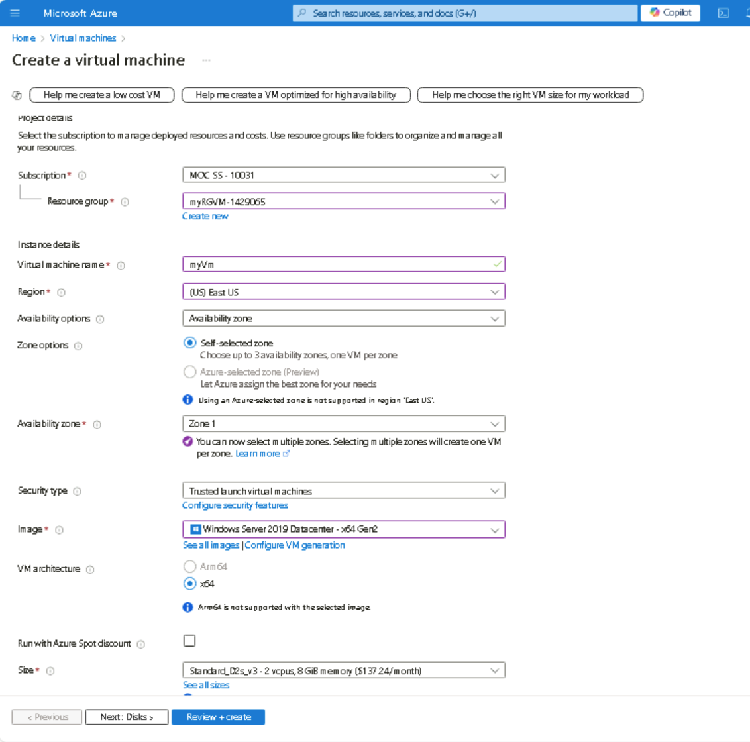

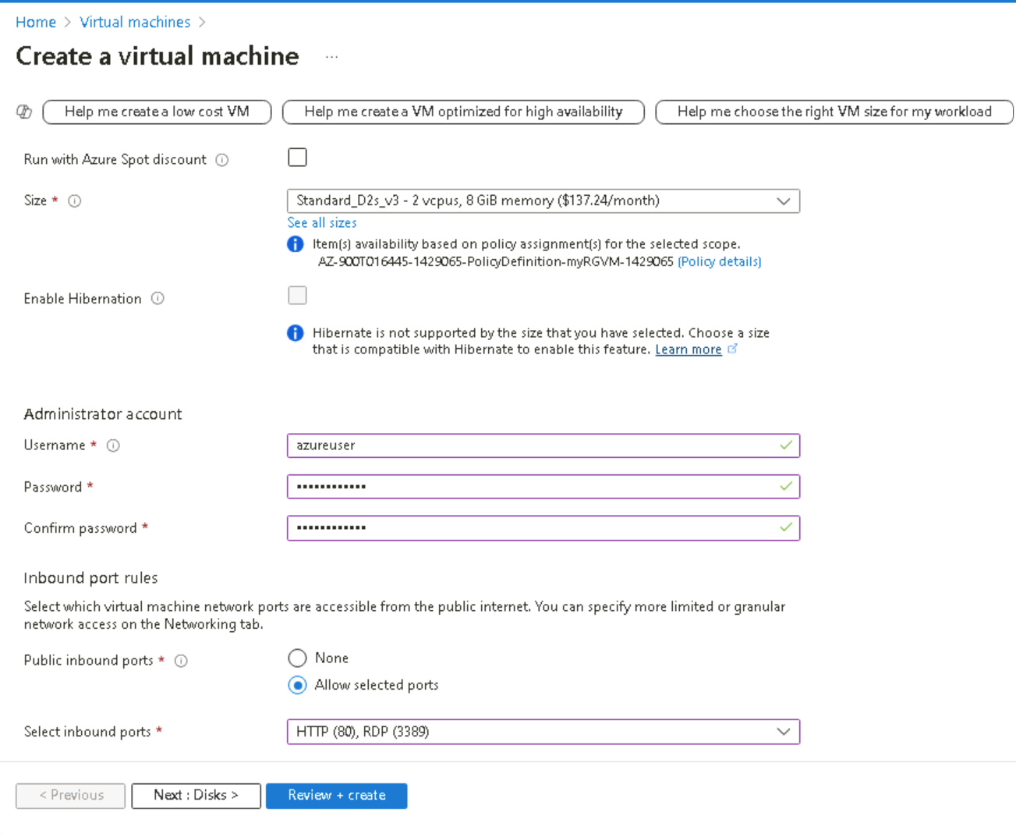
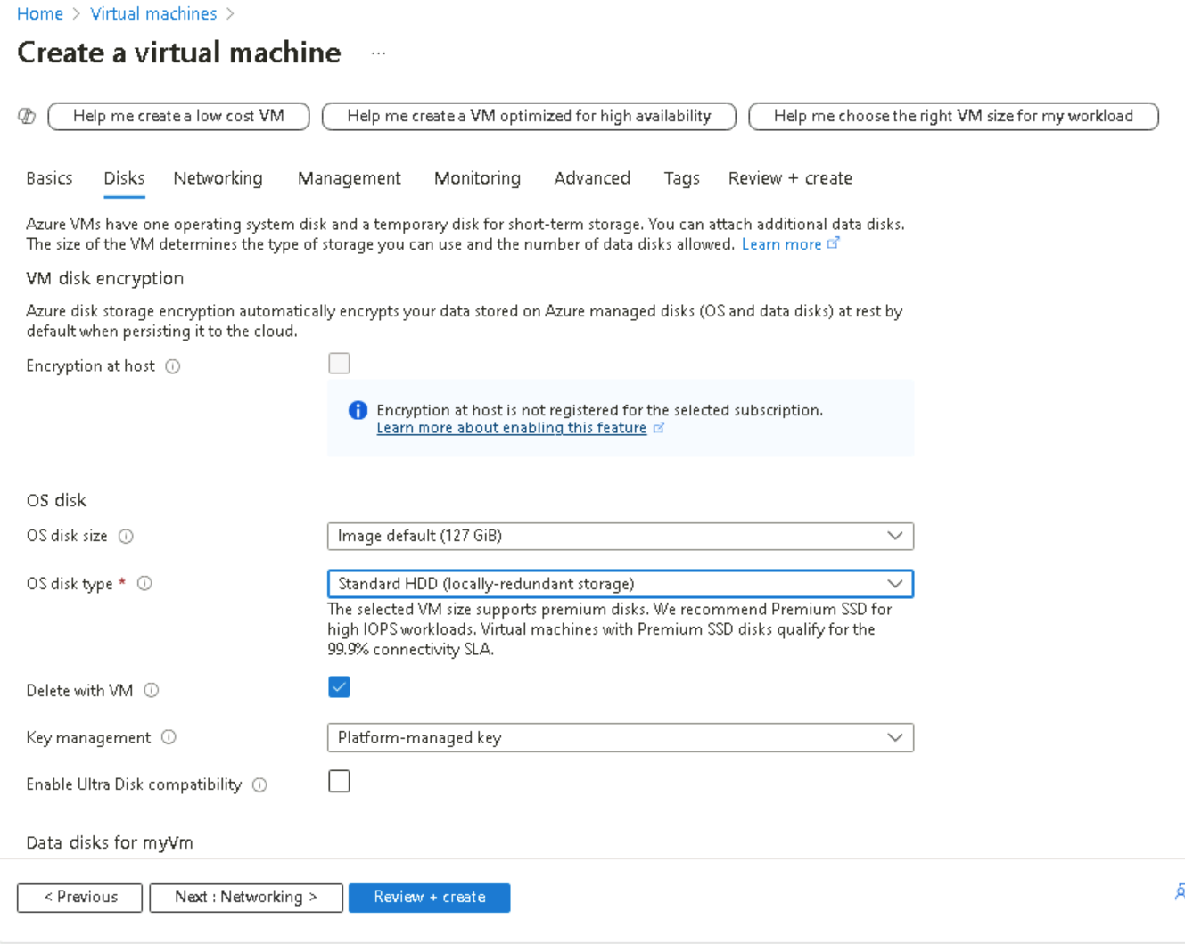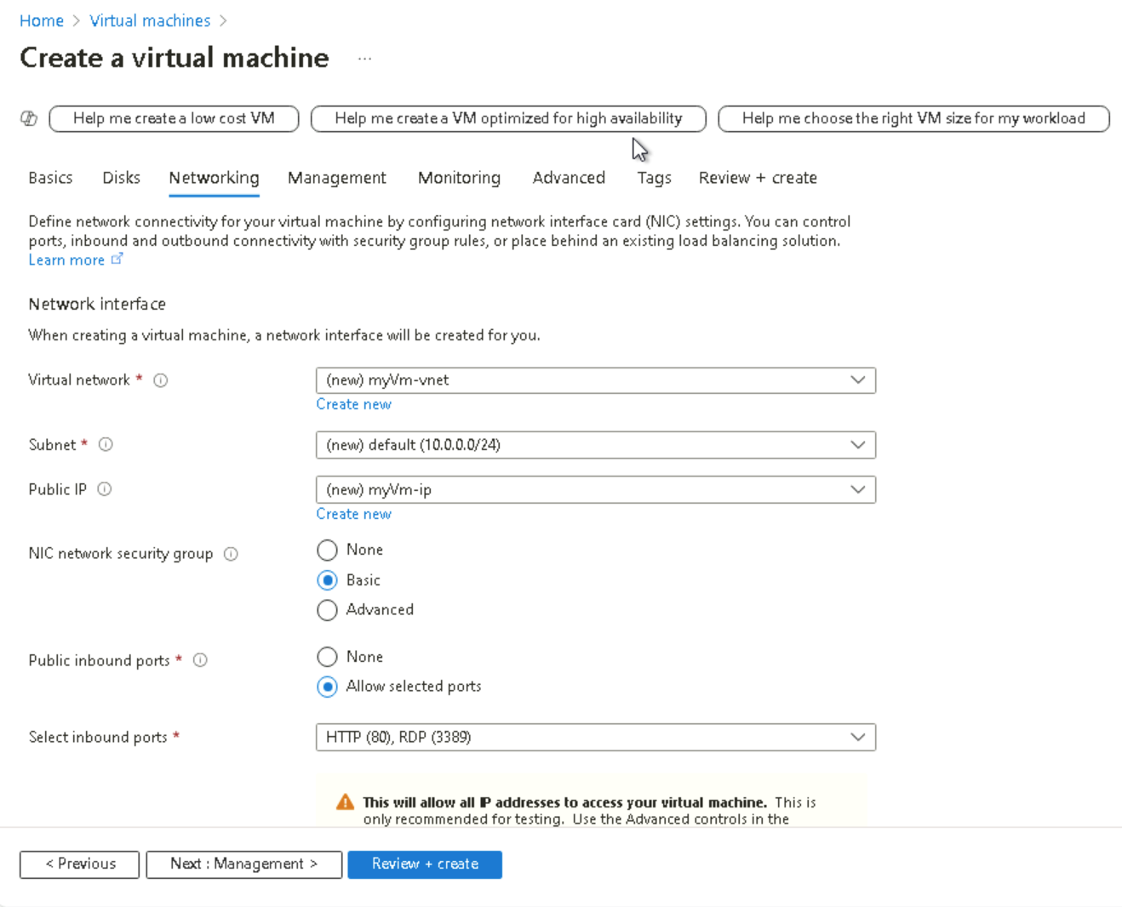
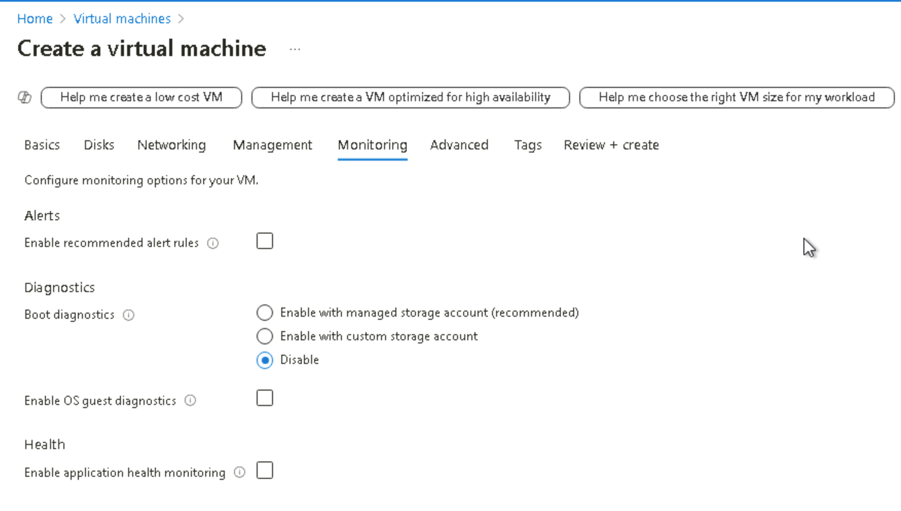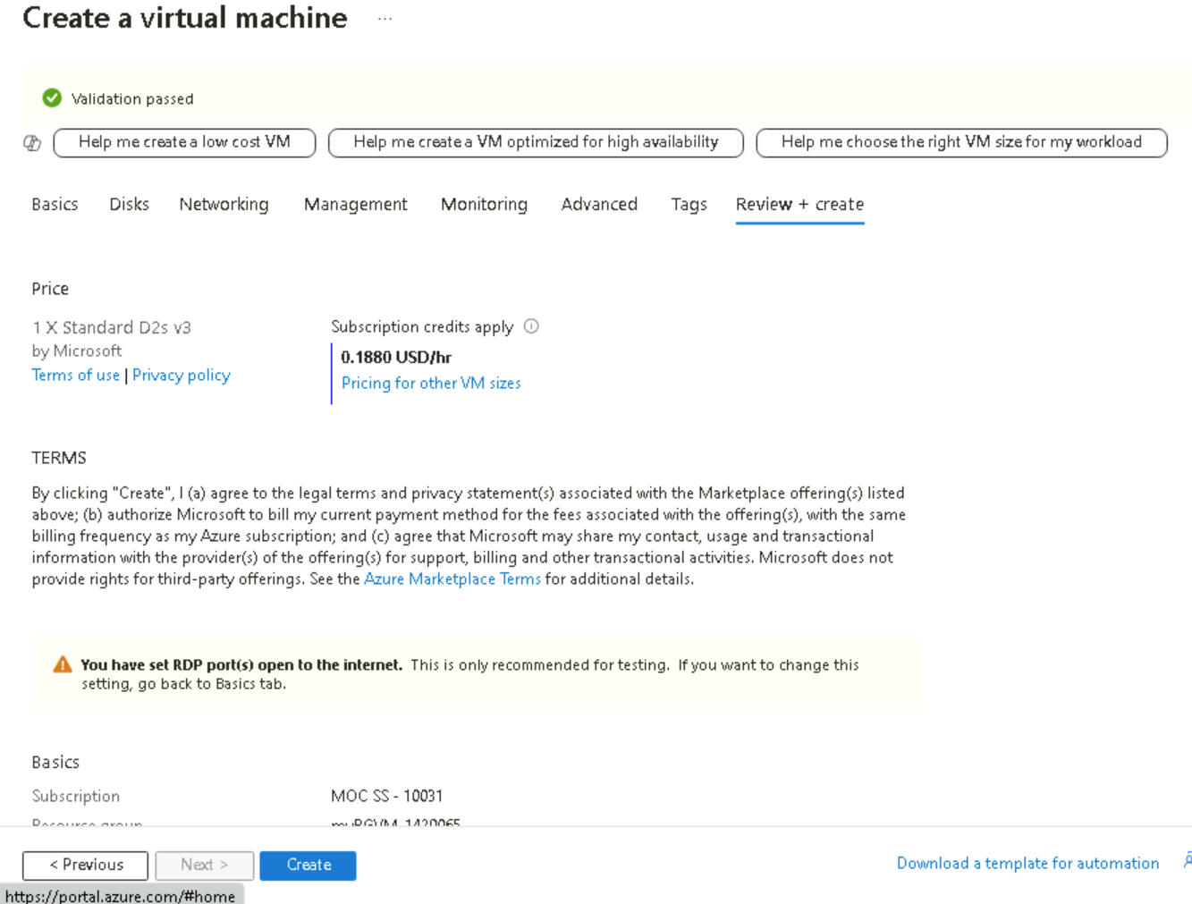
After entering all the information through out the set up tabs for the VM and receiving a validation approval, I deployed the VM.
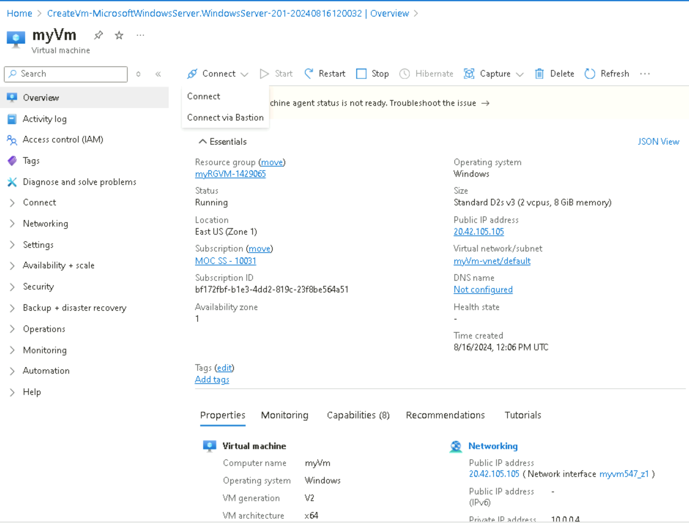
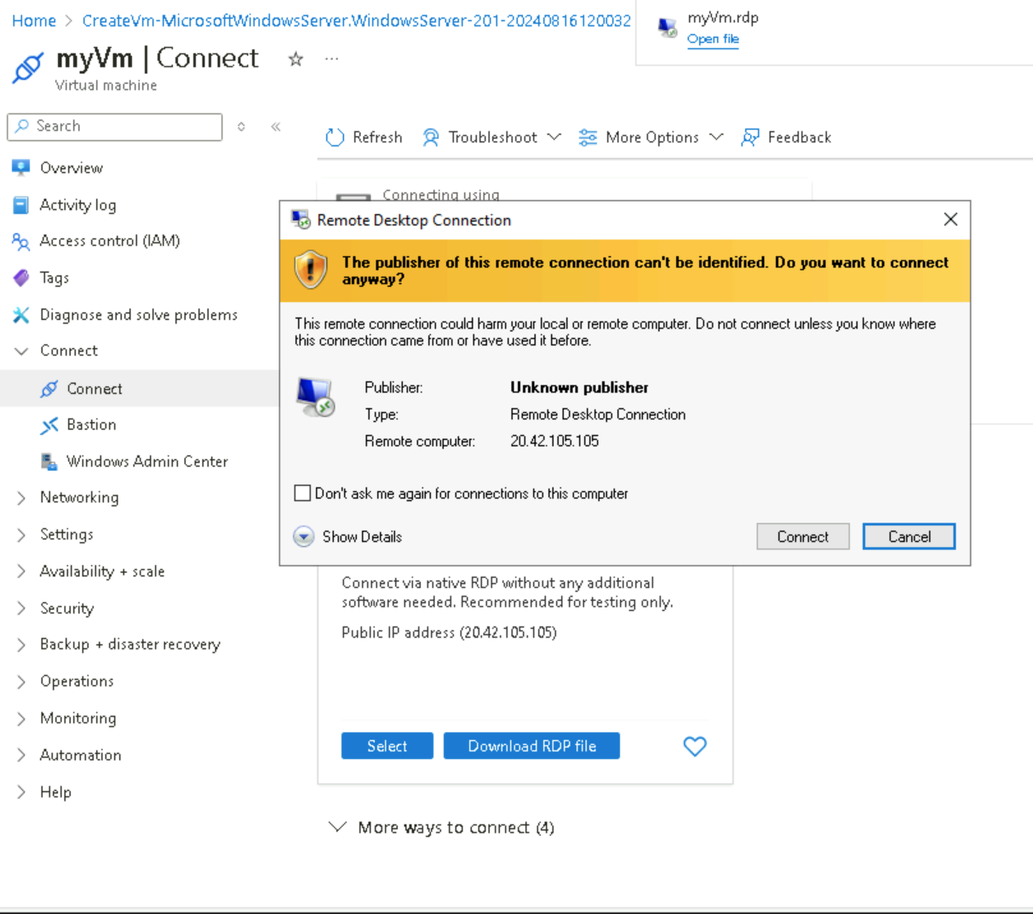
After connecting my VM through the Remote Desktop Protocol (RDP) downloaded file I launched “myVm”.

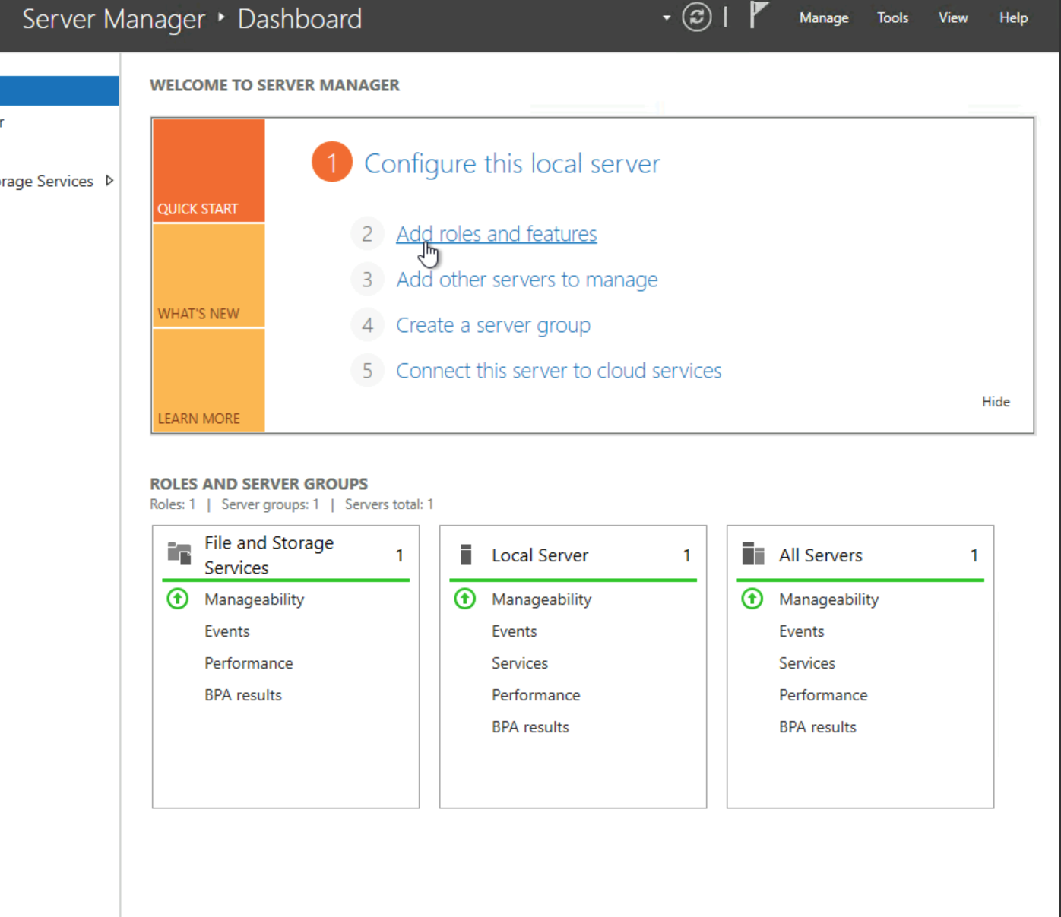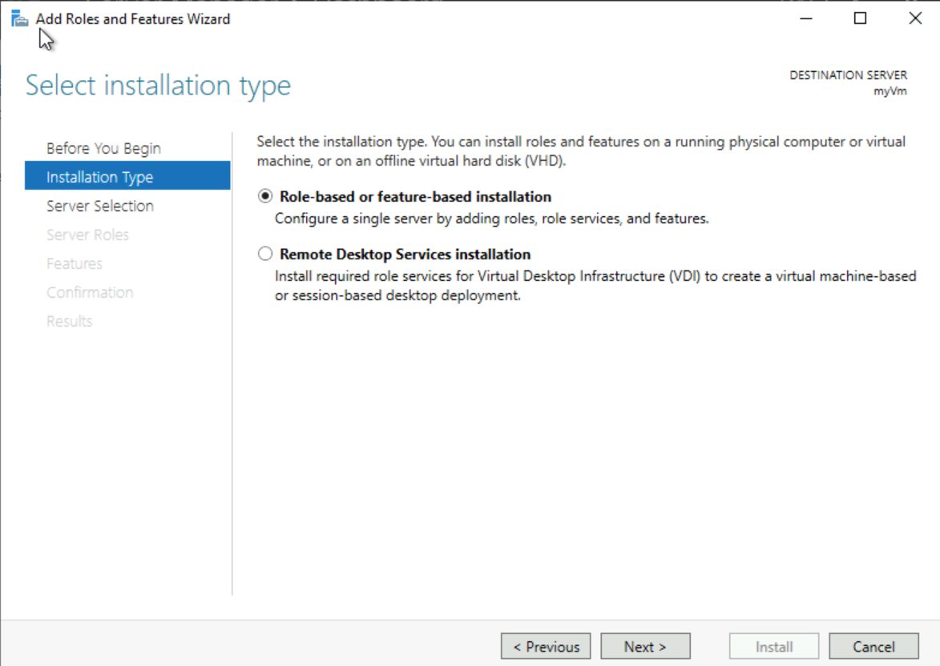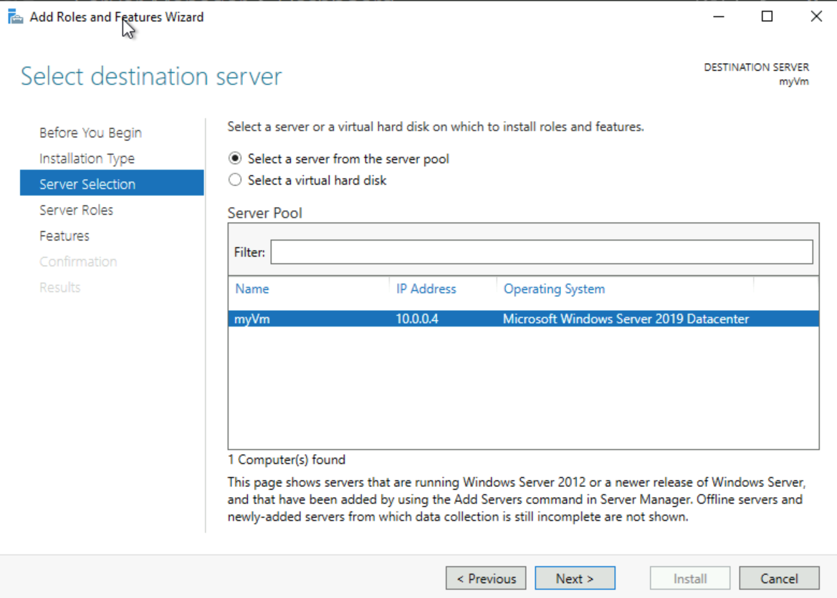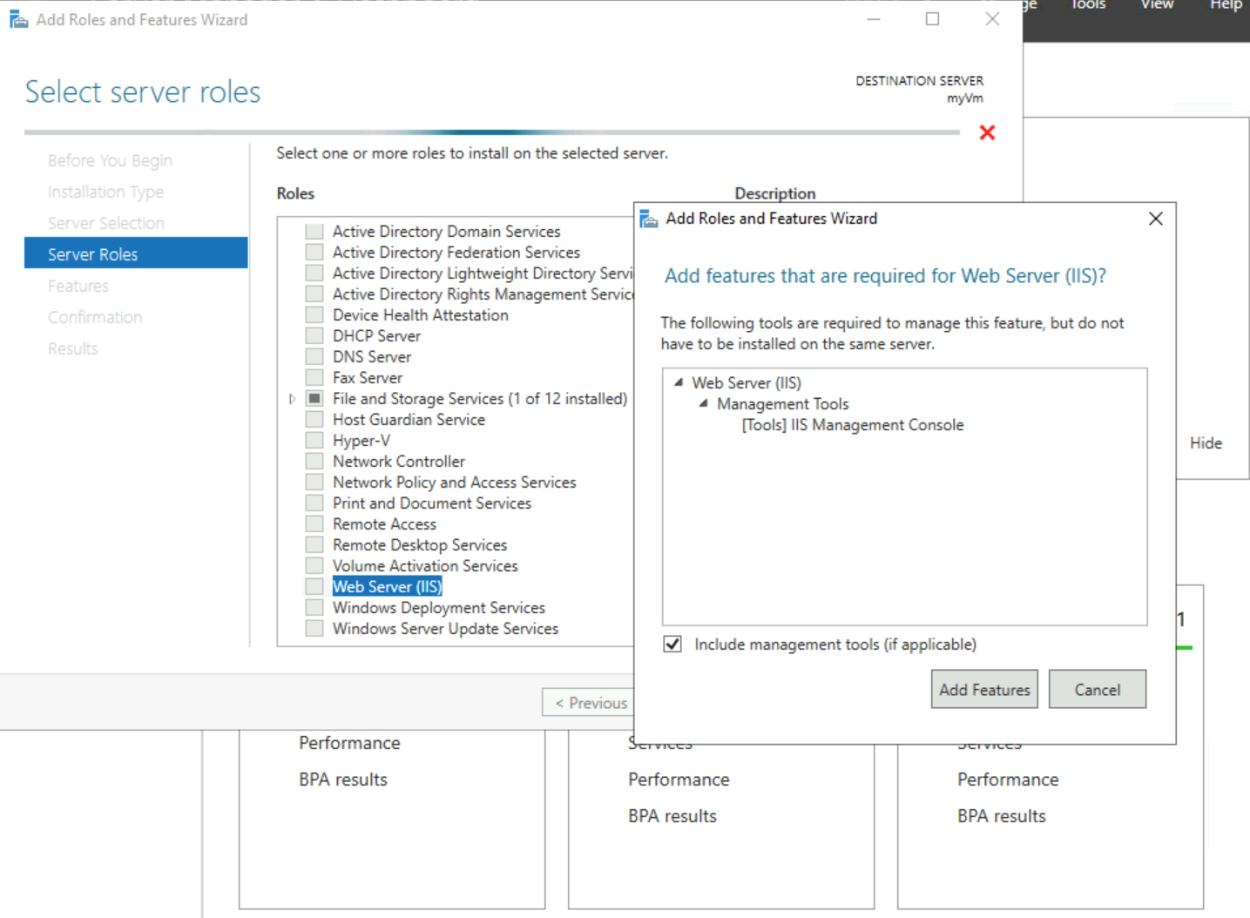
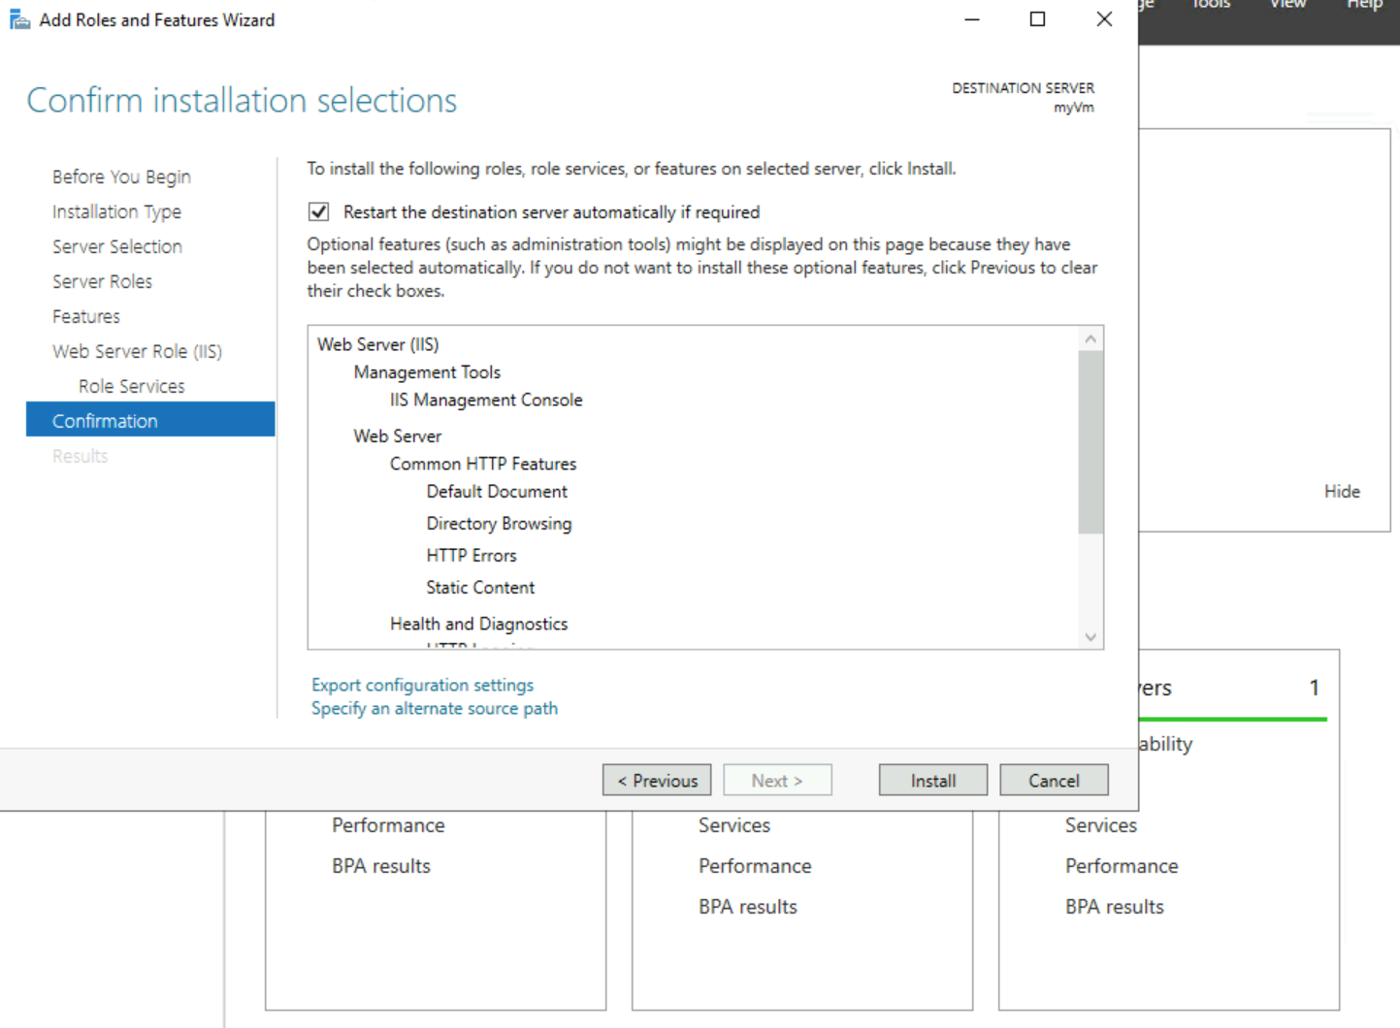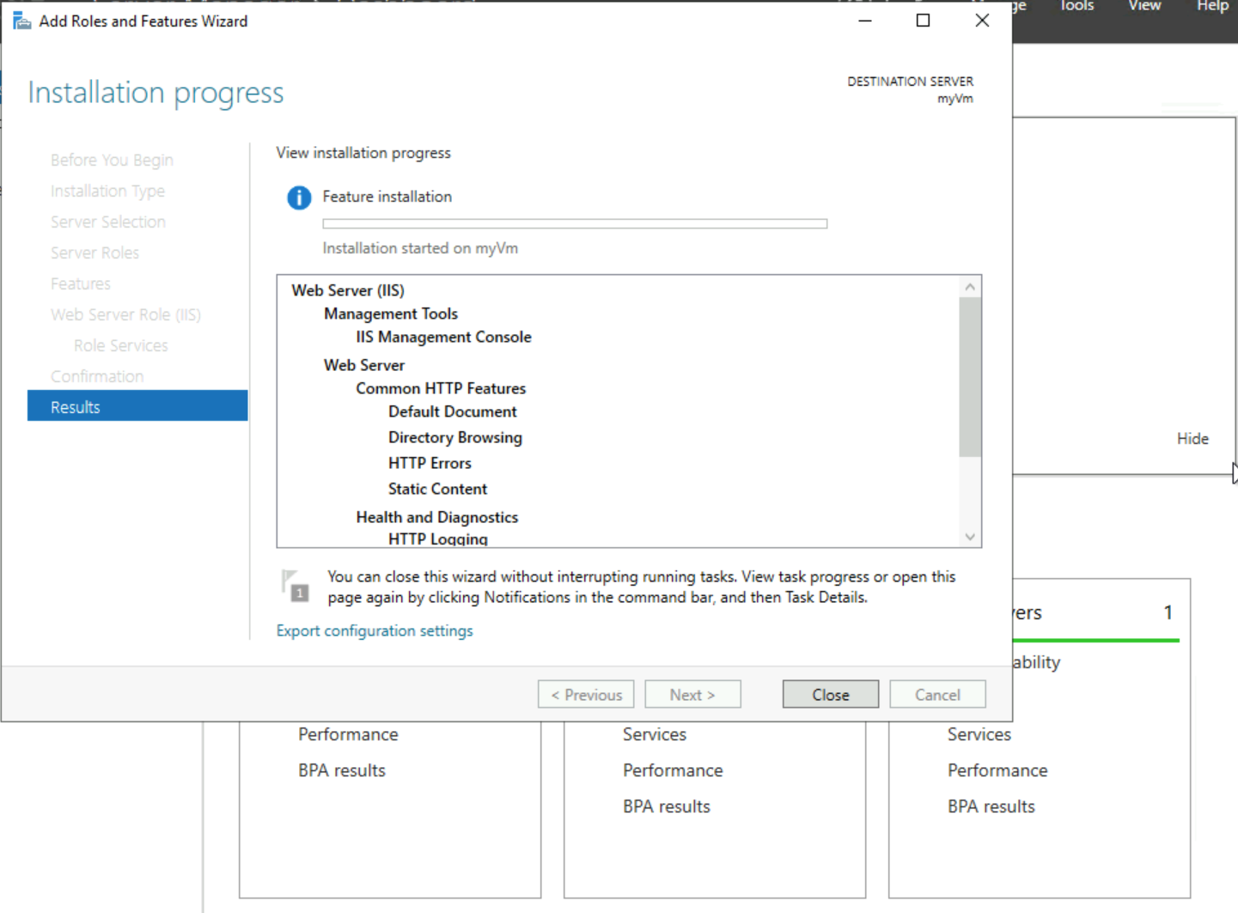
After ensuring that all the right role-based and feature-based were added (server from server pool, Web Server (IIS)), “Restart the destination server automatically”, I proceeded to confirm the installation. In the Internet Information Services (IIS) Manager window, I located your server’s Default Web Site in the Connections tree.
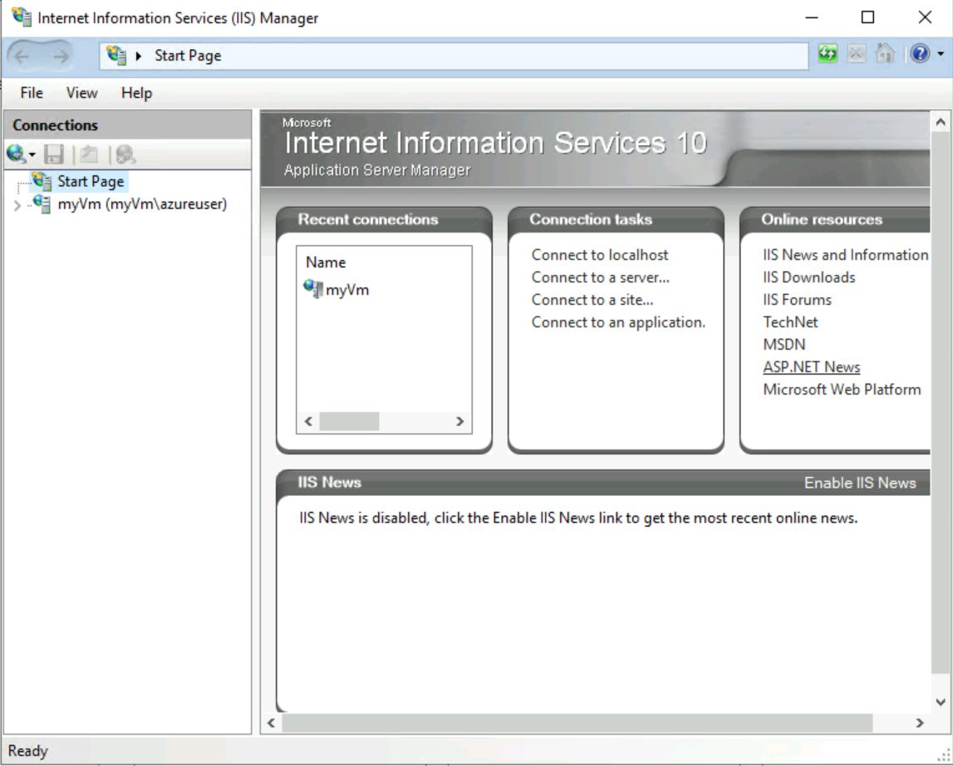
When the installation was complete, I reverted back to the server manager portal: Tools > Internet Information Services (IIS) Manager. In the Internet Information Services (IIS) Manager window, locate your server’s Default Web Site in the Connections tree.

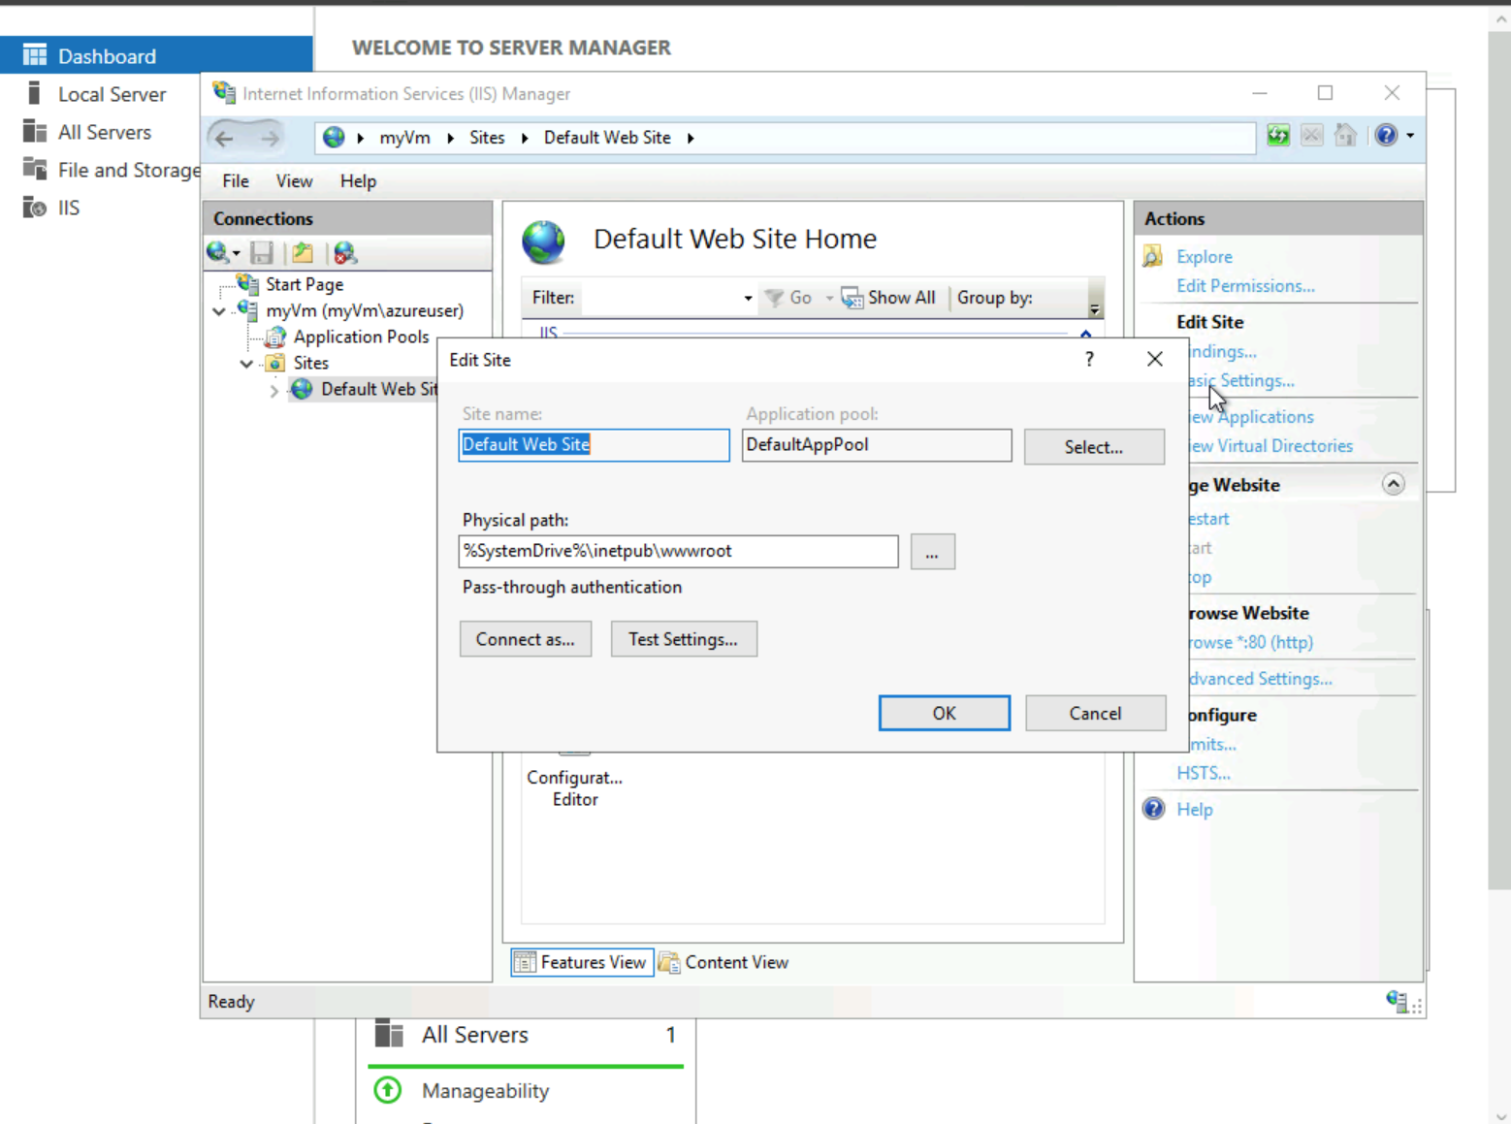

On the ‘Basic Settings’ in the ‘Actions’ menu, the new pop-up dialog box, I located the Physical Path and click Ok. I wrote this basic html content on a notepad and saved the file as ‘default.html’ into that same physical path folder.
<html>
<body>
<h1>Demo Website</h1>
<p>This is my first cloud hosted website.</p>
</body>
</html>
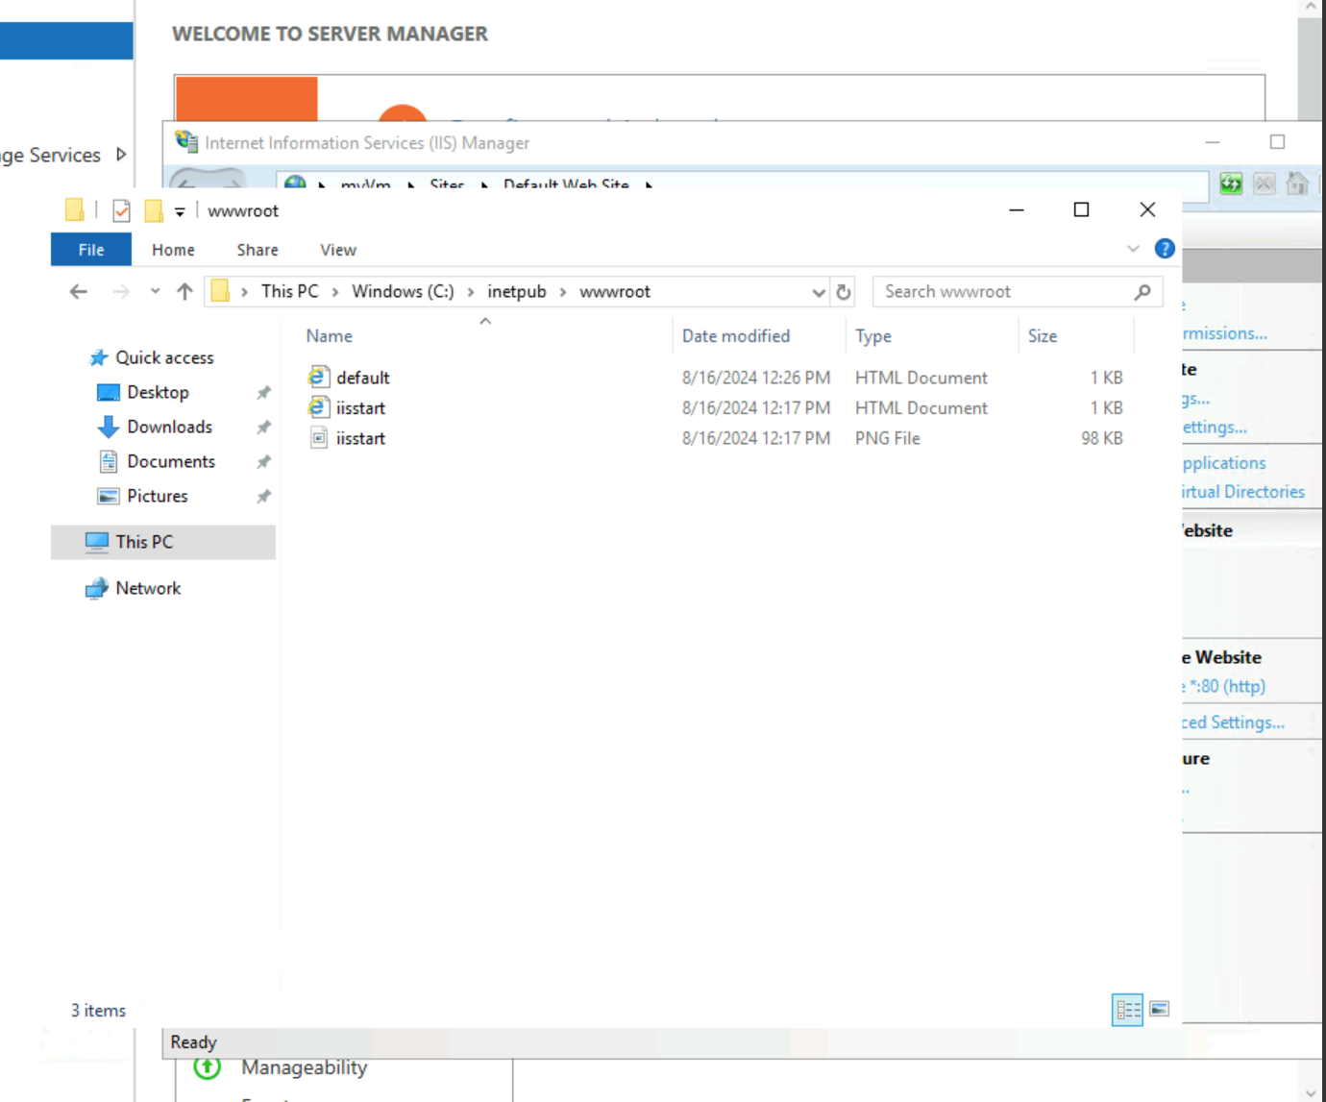
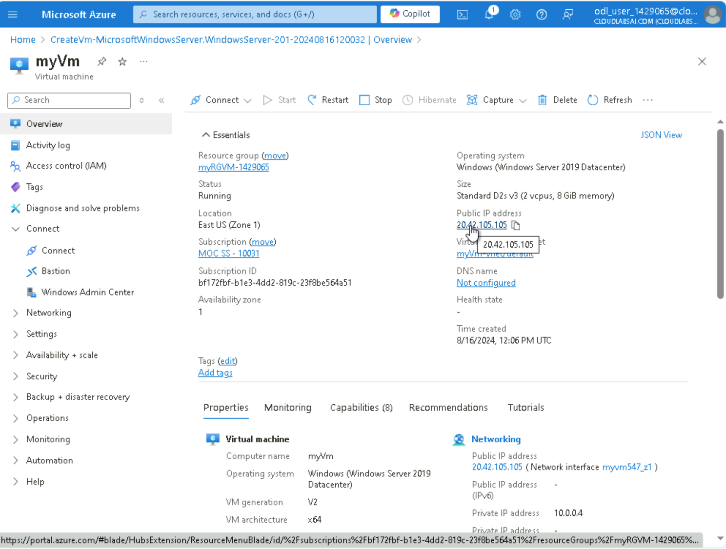
Returning to the Azure portal, I navigated my way to the Overview blade and used the copy to clipboard function to copy the public IP address of “myVm”. I proceeded in opening a new browser tab to paste the public IP address into the URL text box. The custom created basic HTML content shows up as followed.

